](https://yuvalrozner.github.io/Icook)**A18 –** final Submission

**Dor Shabat - 316575620  
Yuval Rozner - 207756552  
Niv Dahan - 308215086  
Nitzan Ezra - 208697334**

Direct link to the website: <https://yuvalrozner.github.io/Icook>

Link to the repository: <https://github.com/YuvalRozner/Icook>

**Assignments**

|  |  |  |
| --- | --- | --- |
| **שם חבר צוות** | **משימות שהוקצו** | **משימות שהושלמו** |
| **דור** (מהנדס מערכת) | 1. ארכיטקטורת האתר – מעבר לreact . 2. כתיבה מחדש של חלק מהקוד ב react . 3. כתיבת תיק – user guide. | כל המשימות |
| **יובל** | 1. ארכיטקטורת האתר – מעבר לreact . 2. כתיבה מחדש של חלק מהקוד ב react . 3. כתיבת תיק programing manual . | כל המשימות |
| **ניצן** | 1. ארכיטקטורת האתר – מעבר לreact . 2. כתיבה מחדש של חלק מהקוד ב react . 3. עדכון use case | כל המשימות |
| **ניב** | 1. ארכיטקטורת האתר – מעבר לreact . 2. כתיבה מחדש של חלק מהקוד ב react . 3. עדכון דרישות | כל המשימות |

**Requirements**

|  |  |
| --- | --- |
| **FR** | |
| System shall allow users to choose a recipe from a recipes list. | |
| System shall allow users to view detailed recipes. | |
| System shall feature a "Cook with Me" interactive cooking assistant. | |
| System shall offer Manual mode. | |
| System shall offer Automatic mode. | |
| System shall provide a progress bar. | |
| System shall allow users to control the timer. | |
| System shall enable users to adjust recipe quantities. | |
| **NFR** | |
| **Requirement** | **Type** |
| The website shall be user-friendly, with intuitive navigation and a responsive design suitable for various devices (desktop, tablet, smartphone). | Usability |
| The website shall provide images for recipes, steps instructions and cooking progress. | Usability |
| The website shall load within 3 seconds on standard broadband connections, and recipe steps shall advance smoothly in "Automatic Mode" without lag. | Performance |
| The system shall support an increasing number of users and recipes without degradation in performance or usability. | Scalability |
| The website shall be available 24/7 | Availability |
| The website’s codebase shall be structured and documented to facilitate easy updates, bug fixes, and feature enhancements. | Maintainability |
| The website shall offer customization options for users, such as theme selection, layout preferences, and notification settings, to enhance the personal user experience. | Customization |
| Adjust recipe quantities will based on the number of serving the user choose. | Customization |
| Manual mode, Automatic mode, Progress bar, timer, timer controllers, recipe adjustments – will all be a part of the "Cook with Me" feature. | Structure |
| The website must maintain high-quality, engaging, and error-free content to attract and retain visitors. | Content Quality |
| The design should focus on simplicity and ease of use, avoiding unnecessary elements. | Design |

**Architecture**

**Use Case**

**4.** א. דיאגרמת התיקיות והקבצים:

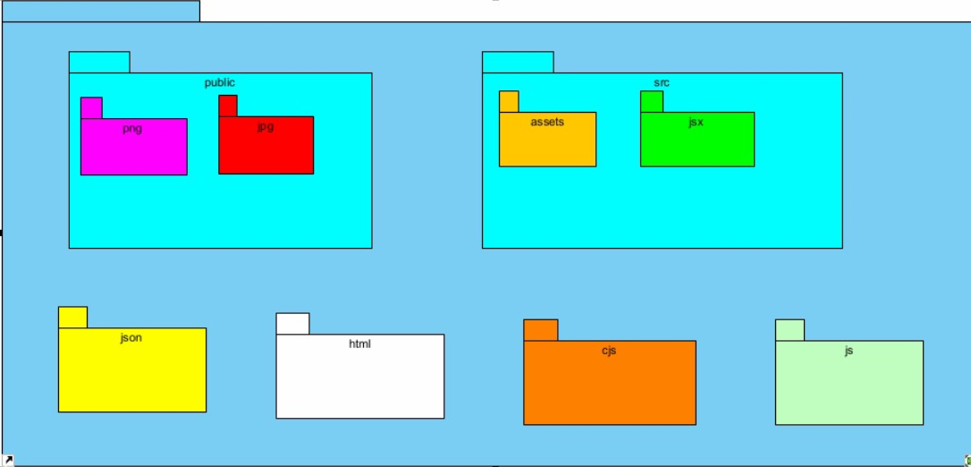

ב. מבנה הDB:  
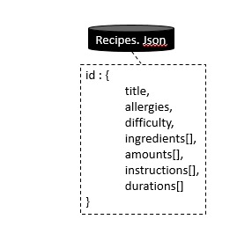

**Programmer's guide**

**in a separate file –** [**Link to file**](Programmer%20Manual.docx)

**User's Guide**

**in a separate file –** [**Link to file**](User%20Guide.docx)